HUSACCT Eclipse plug-in manual



Content

Introduction 3

System requirements 4

Installing Eclipse 5

Installing HUSACCT Eclipse plug-in 6

Start working with the HUSACCT plug-in 7

Analysing a project with the plug-in 10

Validate workspace 10

# Introduction

When you start using the HUSACCT Eclipse plug-in this document might be a good help. For the users who don’t have Eclipse we start with a guide for installing Eclipse.

After installing Eclipse the HUSACCT Eclipse plug-in is ready to be installed. A short and easy description about installing the plug-in can be found in this document.

Now that the HUSACCT Eclipse plug-in is installed it could be confusing when starting with the plug-in. A couple of tips about how to start the plug-in perspective are described. Also the new features compared to the standalone are explained in this document.

After reading this document you should be able to use the HUSACCT Eclipse plug-in.

# System requirements

**Operating system:** Windows XP

**Eclipse version:** Helios

# Installing Eclipse

1. Download the latest version of Eclipse from [www.eclipse.org](http://www.eclipse.org)

(Indigo: <http://www.eclipse.org/downloads/download.php?file=/technology/epp/downloads/release/indigo/SR2/eclipse-jee-indigo-SR2-win32.zip>)

1. Unzip the downloaded .zip file on the location you want it.
2. When this is ready you will find an eclipse folder on your specified location.
3. Open the eclipse folder
4. Double-click the eclipse.exe file and your eclipse will start running
5. A pop-up will appear asking you to select a workspace. (picture 1)
6. If you already have a workspace, browse to this workspace and press OK
7. If you don’t have a workspace, create an empty folder somewhere and select this as your workspace and press OK.
8. Now eclipse is opened and you are ready to create your software.

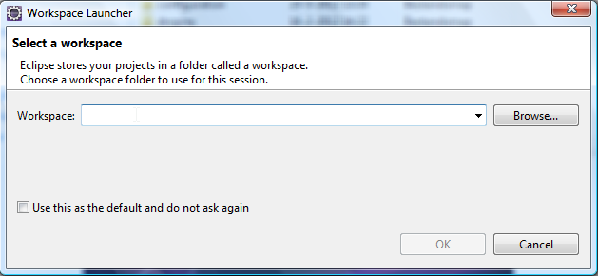

(picture 1: workspace pop-up)

# Installing HUSACCT Eclipse plug-in

1. Download the latest version of the plug-in from: <https://dl.dropbox.com/u/7454879/HUSACCT-PLUGIN_1.0.0.201206051743.jar>
2. Open the Eclipse folder of the eclipse you want to use for the plug-in.
3. Open the “Dropins” folder within the eclipse folder.
4. Place the .jar of the HUSACCT plug-in within the “Dropins” folder.
5. Restart your Eclipse and the plug-in is ready to be used.

# Start working with the HUSACCT plug-in

1. When your Eclipse is started with the .jar of plug-in in the “Dropins” folder (result of the previous chapter) there are a couple of options.
2. You are able to open the perspective through the extra button in the menubar (see picture 2)
3. A second way to open the HUSACCT-perspective is: Press “window” in the menubar > Open perspective > Other… > Select HUSACCT (see picture 3)
4. If you want to use specific views of the HUSACCT -perspective do the following: “window” in the menubar > Show view > Other… > Open the HUSACCT folder and select the view you want to use (see picture 4)
5. When right-clicking a project a menu will appear which has a couple of HUSACCT options. Start with analyse project. If a HUSACCT option is clicked the HUSACCT -perspective will open.
6. Read the help information in the startview for more information about the use of the plug-in.



(picture 2: menu bar of eclipse)

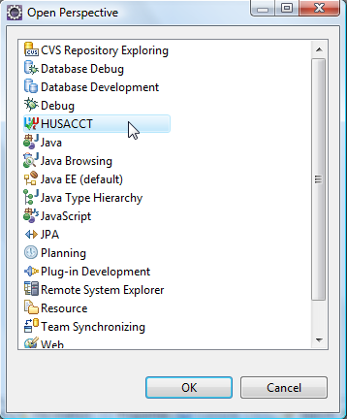

(picture 3: Perspective overview with HUSACCT selected)

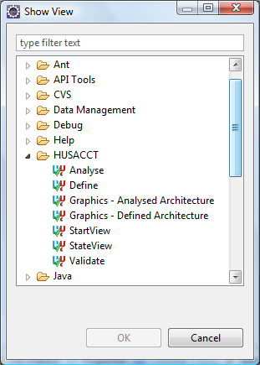

(picture 4: Overview of all the views with the HUSACCT folder opened)

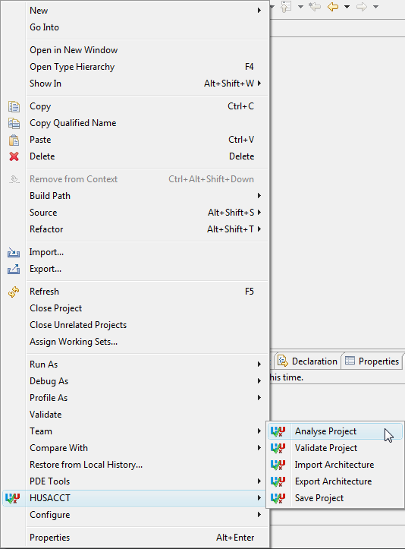

(picture 5: Menu when right-clicking a project in Eclipse. Start with analysing a project)

# Analysing a project with the plug-in

For the use of the HUSACCT functionalities please read the global manual of HUSACCT.

In this manual only the Eclipse plug-in options will be explained.

Let’s start with the content of the right-click options which are shown in picture 5:

* **Analyse project:** A workspace will be created for the selected eclipse project. Also the project will be analysed and you are now able to define and map your architecture. The define view, analyse view and graphics – analysed architectuur view are enabled after this action. The state of the workspace will be updated to analysed.
* **Validate project:** If the workspace is at the right state(Mapped) the button will be enabled. By clicking this option the workspace will be validated. The validate view will be enabled and the table in this view is filled with violations. Only if there are violations. The state of the workspace will be updated to “validated”.
* **Import architecture/export architecture:** Opens a dialog, the functionality is the same as in the standalone version of HUSACCT and is described in the global manual.
* **Save workspace:** After clicking this option the workspace will be saved in a hussact.hu file. This file is saved in the root of the eclipse project. When later analysing a project which contains a hussact.hu file it will automatically load all the information in the different views.

## Validate workspace

Another functionality which is new compared to the standalone version of the HUSACCT is the validate view. In the validate view you are able to go to the source of the violations. When double-clicking a violation in the table, the Java file will directly open next to the HUSACCT views. The editor will be opened on the line number where the violations occurred. To make it very easy to browse and open the violations, drag the validate view underneath the editor. Now you can open violations easily while watching the source.

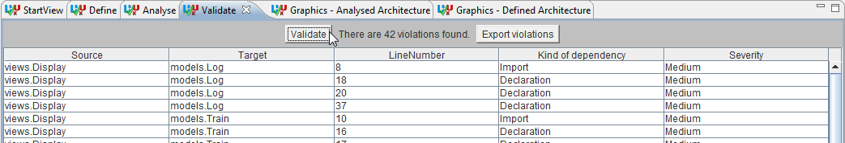 (picture 6: Validate view)